GEORGIA AVENUE FAMILY SUPPORT COLLABORATIVE (GAFSC)
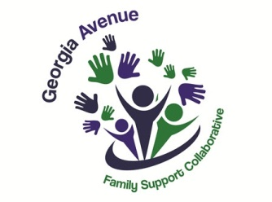
& the Community Schools Initiative (CSI)

Scholarship Application Form
Roosevelt stay High School SY 2022-2023

STUDENT INFORMATION

Last Name:

First Name: Middle Initial:

DCPS Student ID #:

Address:

Telephone Number: Home__________________________ Cell Phone Number_______________

Email Address:

Date of Birth: Month Day: Year: Gender (circle one): M F

Cumulative Grade Point Average (GPA) on a 4.0 scale*: (Attach current transcript)

Are you the first person in your family to go to college? Yes______ No______

Signature: Date:

- If you have decided on what college-university you will attend, please list the school’s name (acceptance letter must be attached): If not, list your top three college choices:
1)
2)
3)
NOTE IMPORTANT *Please attach to this application proof of your GPA; the most recent school transcript is preferred, acceptance letter from the college admissions, the essay and resume. (INCOMPLETE APPLICATIONS will not be accepted) See the attached application checklist
Please submit by February 17, 2023 via email.
COMPLETE and submit the Photo and Story Release Form

- RESUME: Provide a typed resume that includes the following:

- Any academic honors, awards and membership activities while in high school

- Your hobbies, outside interests, extracurricular activities and school-related volunteer activities

- Non-school-related volunteer activities in your community

- ESSAY: Provide a typed 500-750-word essay on one of the following topics: (Please write your name on the essay.)
- A challenge you have experienced (academic-, life- or sports-related) and the steps you took to overcome it, the lessons you learned and the results of your efforts.

- Your future academic and career plans, what has influenced your decision-making and where do you see yourself in ten years.

- A current events topic that you are passionate about, why you are interested in the issue and your plans for involvement. Also include information on the overall societal implications of this issue and the solutions you envision to address it.
Submit the completed GAFSC Scholarship Application Form and all required application materials no later than 5pm on February 17, 2023, by email to Ms. Veronica Gonzalez at vgonzalez@gafsc-dc.org

